Project of IT 315

Iris Flower Classification Project Report

Afnan Alsaleem
ID: 432218054

Introduction
Machine Learning has become one of the most important technologies in modern computer science because it allows computers to learn from data and make intelligent decisions without being explicitly programmed. One of the common applications of machine learning is classification, where a system predicts categories based on input data.

This project aims to classify Iris flowers into one of three species:
- Setosa
- Versicolor
- Virginica
The classification is based on four flower features:
- Sepal Length
- Sepal Width
- Petal Length
- Petal Width

The project uses Machine Learning algorithms from the Scikit-learn library and provides a graphical user interface (GUI) using Tkinter.

Purpose | Library
Data handling and analysis | Pandas
Data visualization | Seaborn
Plotting graphs | Matplotlib
Machine learning algorithms | Scikit-learn
Graphical User Interface | Tkinter
Software Architecture

  - Technologies and Libraries Used

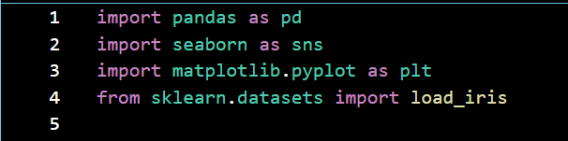


- System Design :
  - Data Loader Class
Responsible for loading, exploring, and visualizing the dataset.
Main Functions:
    - load_data()

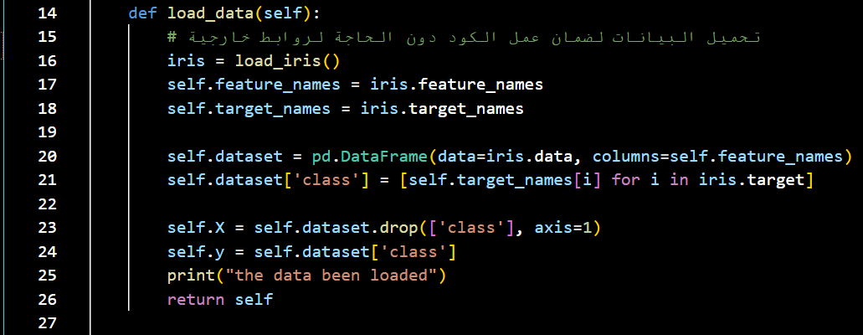
    - explore()

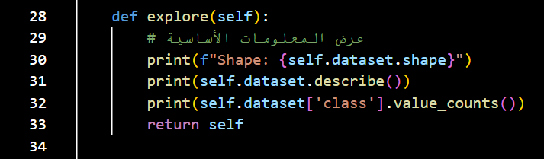

    - plot_data()
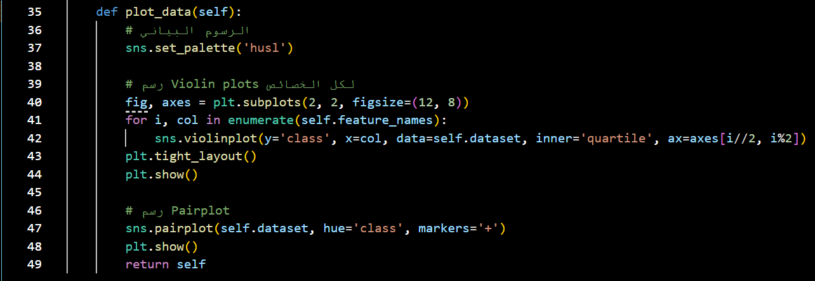

  - Model Manager Class
Responsible for: Splitting data, Training models, Evaluating performance and
Main Functions :
evaluate_multiple_models()
- evaluate_multiple_models()

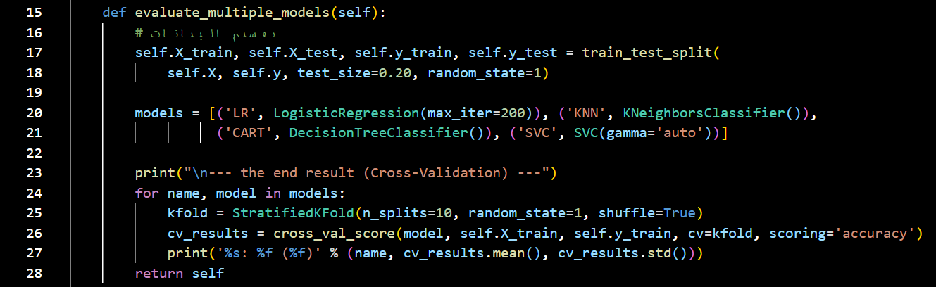

- train_final_model()

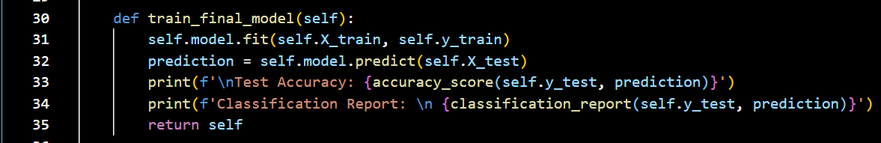

- predict(input_data)
Takes user input values.

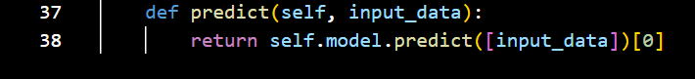

  - IrisGUI Class
Provides a desktop graphical interface for users.
GUI Workflow
- User enters flower measurements.
- User clicks the prediction button.
- The model predicts flower species
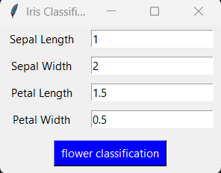
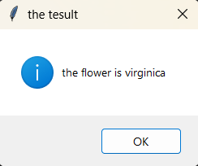
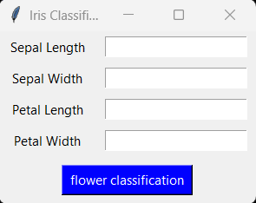
- Result appears in a popup window.

  - Main "Iris APP "Application
IrisAPP.py file controls the full application workflow:
- Load dataset
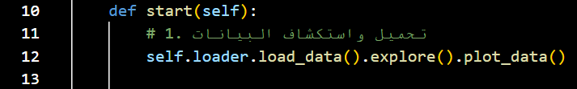
- Explore and visualize data
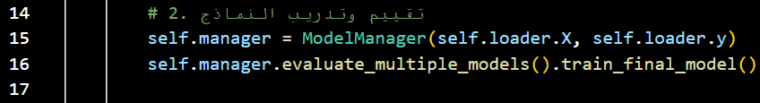
- Train and evaluate models
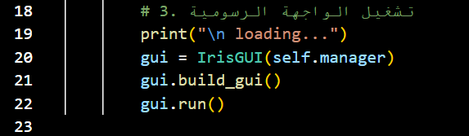
- Launch GUI application

  - Machine Learning Process
The project follows these steps:
- Data Loading
- Data Exploration
- Data Visualization
- Data Splitting
- Model Training
- Model Evaluation
- Prediction
- GUI Deployment

Results:
The models were evaluated using Cross-Validation.The Support Vector Machine (SVM) model achieved high accuracy and was selected as the final model. The application successfully predicts Iris flower species based on user inputs.

Advantages and Challenges of the Project:
Advantages:
- Simple and easy to use
- Uses real machine learning algorithms
- Includes data visualization
- Provides interactive desktop GUI
- Demonstrates complete ML workflow

Challenges:
- Handling GUI input validation
- Selecting the best model
- Organizing project files
- Understanding model evaluation methods

Conclusion:
This project demonstrates the complete process of building a Machine Learning application using Python. The system successfully classifies Iris flowers using different ML algorithms and provides predictions through a user-friendly graphical interface.

References:
The Iris Dataset — scikit-learn 1.5.2 documentation

scikit-learn: machine learning in Python — scikit-learn 1.8.0 documentation

Iris Dataset Classification with Python: A Tutorial - Quark Machine Learning

Iris flower data set - Wikipedia

Iris Dataset - GeeksforGeeks

Youtube: Intro to Machine Learning with Python 2: Exploratory Data Analysis

Python Machine Learning W3shool:

